**Lab 1.2 - .NET command line compiler tools and IL exercise**

d.i.1

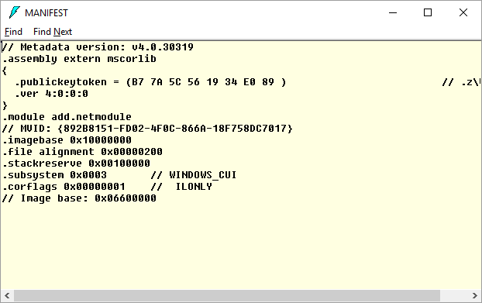

d.i.2

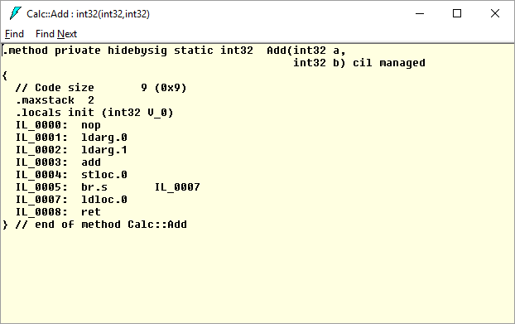

d.i.2.a

IL_0000: nop //do nothing

IL_0001: ldarg.0 //load arg0

IL_0002: ldarg.1 //load arg1

IL_0003: add //add arg1 to arg0, arg0=result, arg1=null

IL_0004: stloc.0 //store the result from arg0 to stack

IL_0005: br.s IL_0007// jump to IL_0007

IL_0007: ldloc.0 //load the result from stack

IL_0008: ret //return

e.ii

The file calc.il contain the code

the file calc.res is the resource object file

e.iii

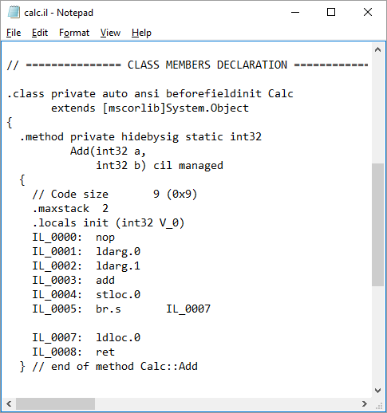

f.ii.2

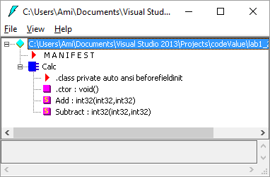

g.iii

we didn’t add the module of calc

g.iv

Add and Subtract are private methods, so program can't use them.

g.ix

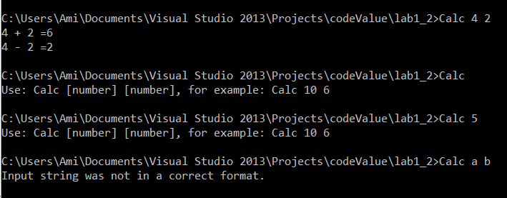

g.x

I see a file with a data for our program

4.

